Test Case:

READ TEST

1. First we will test the cache program with 4 ways and 2 set with read function. The reason I test with 4 ways and 2 set because it is easy for keep track with LRU and MESI bit. If it works with 4ways and 2 set, we can increase the way and set.
2. Second we will test Read hit and see how the LRU update. I still use the same the data in test case 1, but I will add 1 more data to make hit.
3. We will test Read hit 2 time and see how the LRU update. I still use the same the data in test case 1, but I will add 2 more data to make hit.
4. We will test the Evict. When the caches is full, then got the read miss, it need to evict the LRU cache line. According to the test #2. If we read 1 more data into set 0: the address abcde000 will be victim for evict. And after the new address read in set 0 way 0, the LRU of that address will be 3.
5. We also run more test in this case because we want to make sure the LRU Bit update good. We will do read hit first and do the evict so we can check the LRU bit.
6. The last test for Read is miss test. We will do evict , hit, evit, miss, hit together.

FYI: the MESI in this test should be “S” for all output because this is read function. We only check LRU here.

|  |  |  |  |
| --- | --- | --- | --- |
| Case | Address | Expected Results | Verify |
| 1 | 0 408ed4  0 abcde000  0 ffffffff  0 abc456ff  0 12345678  0 99999000  0 ed4f0000  0 678abc9f  9 00000000 | Set 0:  Way 0: LRU 0: MESI : S  Way 1: LRU 1: MESI : S  Way 2: LRU 2: MESI: S  Way 3: LRU 3: MESI: S  Set 1:  Way 0: LRU 0: MESI : S  Way 1: LRU 1: MESI : S  Way 2: LRU 2: MESI: S  Way 3: LRU 3: MESI: S  Data Caches:  Caches Read: 8  Caches hit : 0  Caches miss: 8  Hit Ratio: 0.00%  Instruction Caches:  Caches Read: 0  Caches hit : 0  Caches miss: 0  Hit Ratio: 0.00% | Yes. |

Program Output:

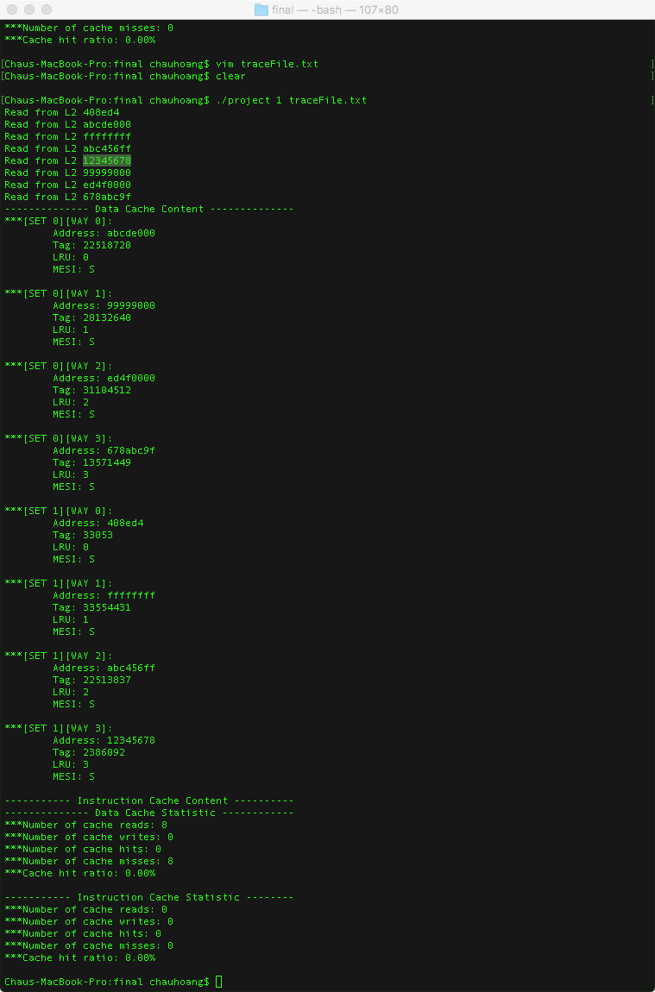

|  |  |  |  |
| --- | --- | --- | --- |
| Case | Address | Expected Results | Verify |
| 2 | 0 408ed4  0 abcde000  0 ffffffff  0 abc456ff  0 12345678  0 99999000  0 ed4f0000  0 ffffffff // this is read hit here.  0 678abc9f  9 0000000 | Set 0:  Way 0: LRU 0: MESI : S  Way 1: LRU 1: MESI : S  Way 2: LRU 2: MESI: S  Way 3: LRU 3: MESI: S  Set 1:  Way 0: LRU 0: MESI : S  Way 1: LRU 3: MESI : S  Way 2: LRU 1: MESI: S  Way 3: LRU 2: MESI: S  Data Caches:  Caches Read: 9  Caches hit : 1  Caches miss: 8  Hit Ratio: 11.1 %  Instruction Caches:  Caches Read: 0  Caches hit : 0  Caches miss: 0  Hit Ratio: 0.00% | Yes |

Program output:

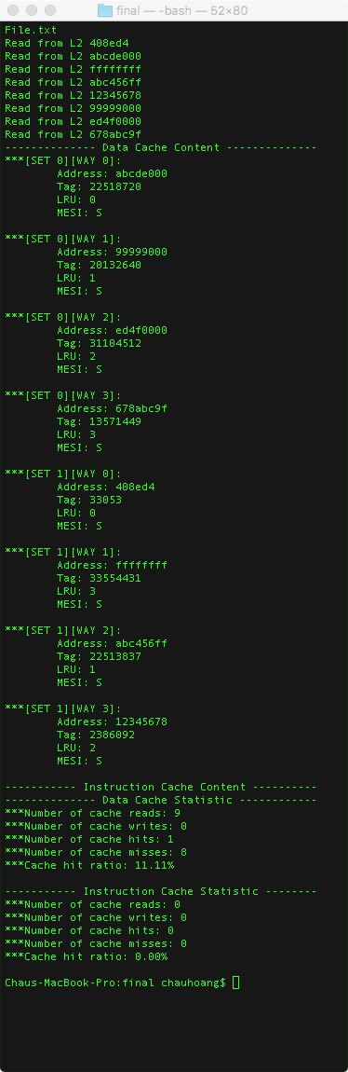

|  |  |  |  |
| --- | --- | --- | --- |
| Case | Address | Expected Results | Verify |
| 3 | 0 408ed4  0 abcde000  0 ffffffff  0 abc456ff  0 12345678  0 99999000  0 ed4f0000  0 ffffffff // this is read hit here.  0 678abc9f  0 12345678// this is hit here  9 0000000 | Set 0:  Way 0: LRU 0: MESI : S  Way 1: LRU 1: MESI : S  Way 2: LRU 2: MESI: S  Way 3: LRU 3: MESI: S  Set 1:  Way 0: LRU 0: MESI : S  Way 1: LRU 2: MESI : S  Way 2: LRU 1: MESI: S  Way 3: LRU 3: MESI: S  Data Caches:  Caches Read: 10  Caches hit : 1  Caches miss: 9  Hit Ratio: 10.00%  Instruction Caches:  Caches Read: 0  Caches hit : 0  Caches miss: 0  Hit Ratio: 0.00% | Yes |

Program output:

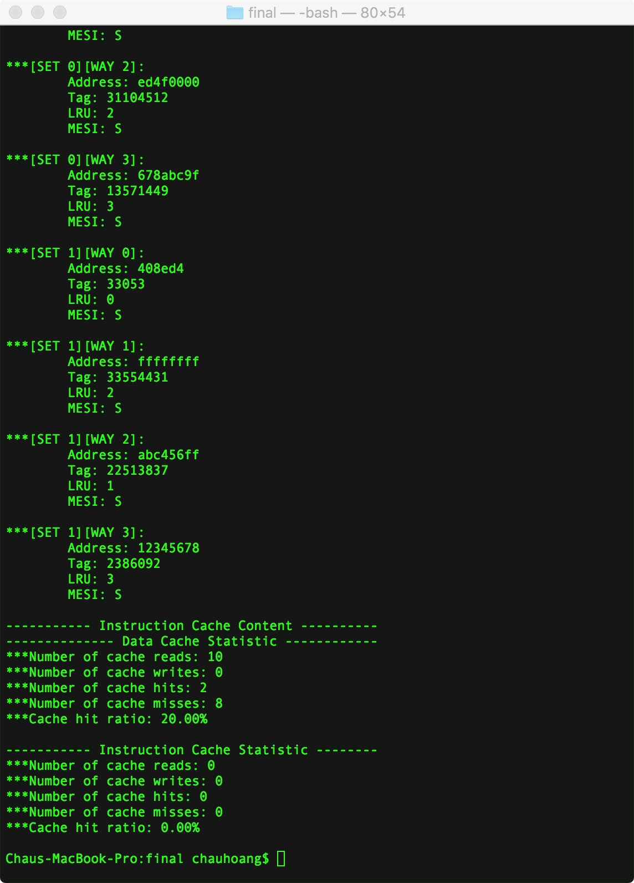

|  |  |  |  |
| --- | --- | --- | --- |
| Case | Address | Expected Results | Verify |
| 4 | 0 408ed4  0 abcde000// this is Evict VICTIM  0 ffffffff  0 abc456ff  0 12345678  0 99999000  0 ed4f0000  0 ffffffff // this is read hit here.  0 678abc9f  0 0bcde000 // this will replace abcde000 line READ MISS  9 0000000 | Set 0:  Way 0: LRU 3: MESI : S  Way 1: LRU 0: MESI : S  Way 2: LRU 1: MESI: S  Way 3: LRU 2: MESI: S  Set 1:  Way 0: LRU 0: MESI : S  Way 1: LRU 3: MESI : S  Way 2: LRU 2: MESI: S  Way 3: LRU 1: MESI: S  Data Caches:  Caches Read: 10  Caches hit : 1  Caches miss: 9  Hit Ratio: 10.00%  Instruction Caches:  Caches Read: 0  Caches hit : 0  Caches miss: 0  Hit Ratio: 0.00% | Yes |

Program Output:

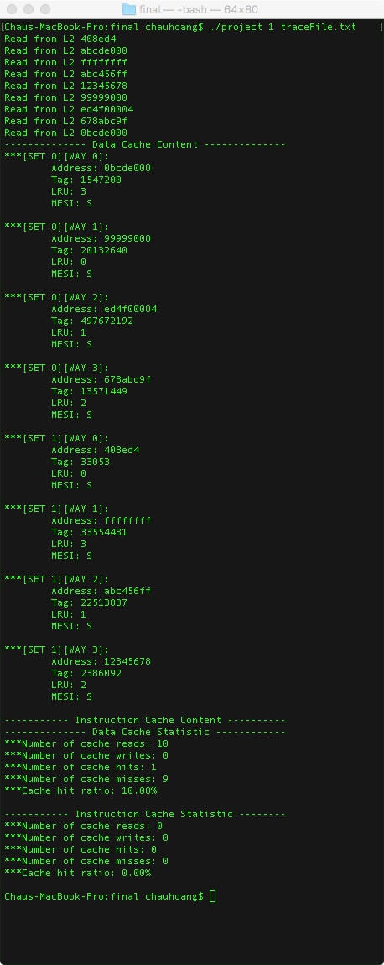

|  |  |  |  |
| --- | --- | --- | --- |
| Case | Address | Expected Results | Verify |
| 5 | 0 408ed4  0 abcde000  0 ffffffff  0 abc456ff  0 12345678  0 99999000// this is VICTIM  0 ed4f0000  0 ffffffff // this is read hit here.  0 678abc9f  0 abcde000 // hit here so this wont be VICTIM anymore  0 0bcde000 // this will replace 99999000  9 0000000 | Set 0:  Way 0: LRU 2: MESI : S  Way 1: LRU 3: MESI : S  Way 2: LRU 0: MESI: S  Way 3: LRU 1: MESI: S  Set 1:  Way 0: LRU 0: MESI : S  Way 1: LRU 3: MESI : S  Way 2: LRU 1: MESI: S  Way 3: LRU 2: MESI: S  Data Caches:  Caches Read: 11  Caches hit : 2  Caches miss: 9  Hit Ratio: 18.18%  Instruction Caches:  Caches Read: 0  Caches hit : 0  Caches miss: 0  Hit Ratio: 0.00% | Yes |

Output:

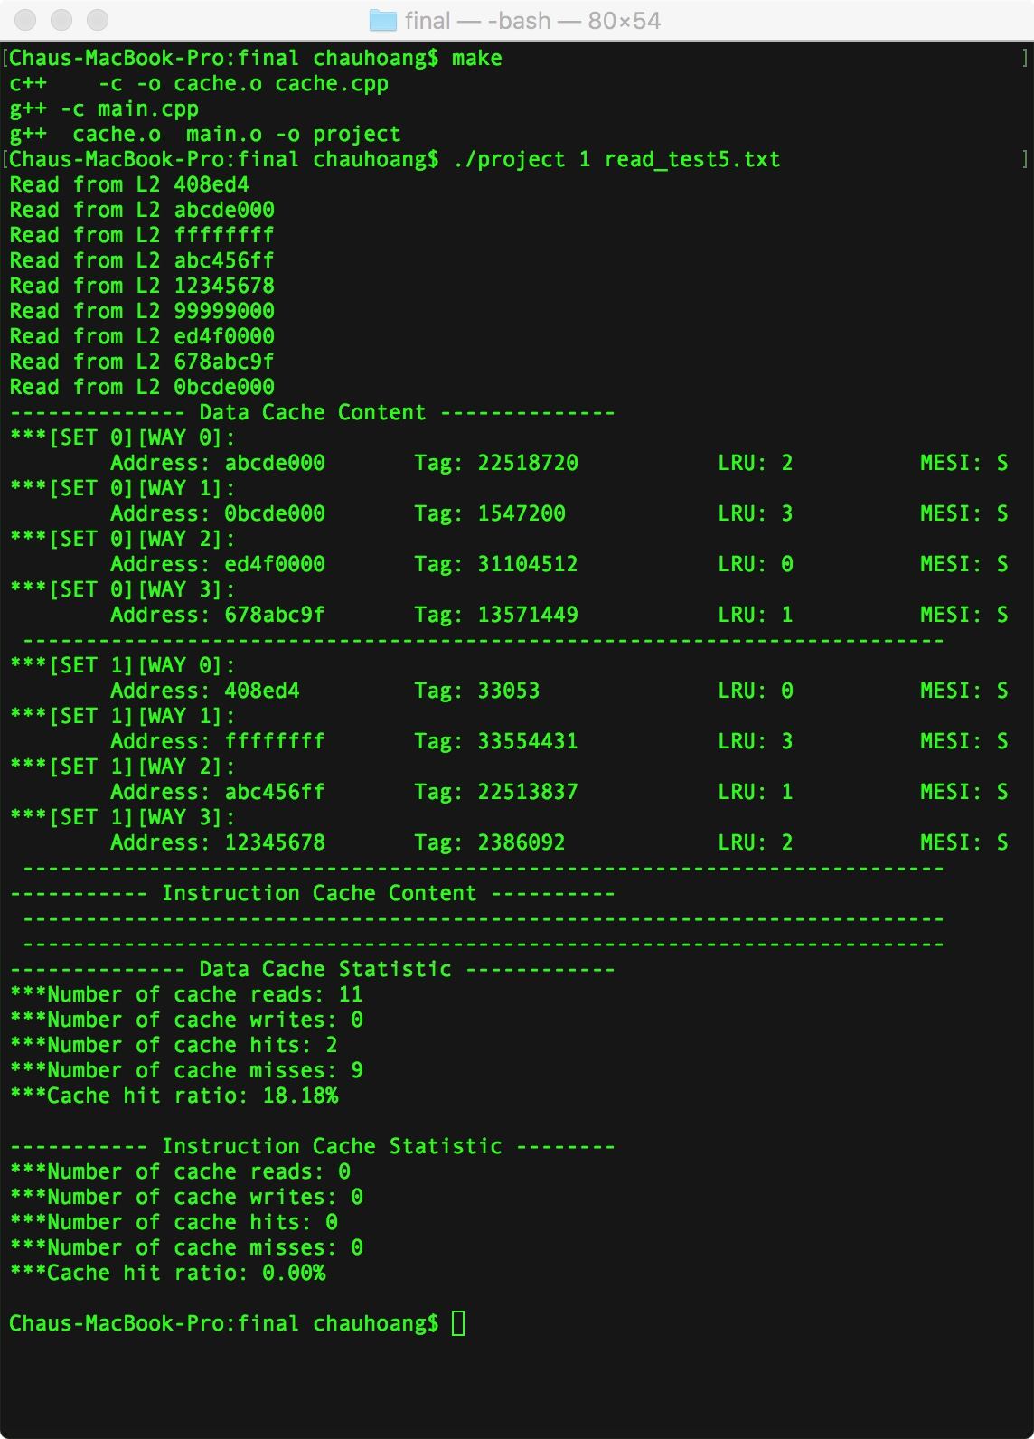

|  |  |  |  |
| --- | --- | --- | --- |
| Case | Address | Expected Results | Verify |
| 6 | 0 408ed4  0 abcde000  0 ffffffff  0 abc456ff  0 12345678  0 99999000  0 ed4f0000  0 678abc9f  0 1234de00  0 ed4f0000  0 99999000  0 10000000  0 408ed4  0 12345678  0 ffffffff  0 abc456ff  9 0000000 | Set 0:  Way 0: LRU 0: MESI : S  Way 1: LRU 2: MESI : S  Way 2: LRU 1: MESI: S  Way 3: LRU 3: MESI: S  Set 1:  Way 0: LRU 0: MESI : S  Way 1: LRU 2: MESI : S  Way 2: LRU 3: MESI: S  Way 3: LRU 1: MESI: S  Data Caches:  Caches Read: 16  Caches hit : 6  Caches miss: 10  Hit Ratio: 37.50%  Instruction Caches:  Caches Read: 0  Caches hit : 0  Caches miss: 0  Hit Ratio: 0.00% | Yes |

Program Output:

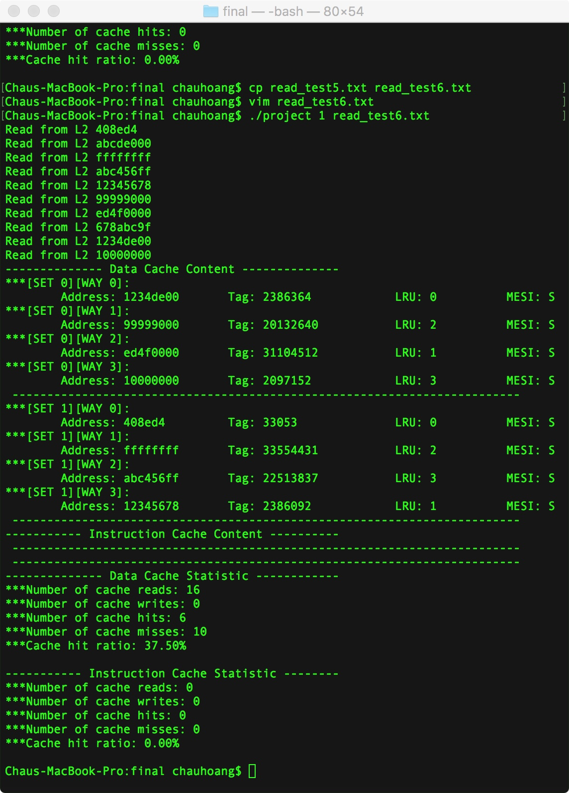

Write test:

1. test write miss when the caches still have spot. Look for LRU bit and MESI bit. If it is first write-> write thought to L2. “ read from L2 first then write -> update LRU bit and MESI bit. If it is second write write back-> update LRU bit and MESI bit.
2. After write miss (1st write ) and write to the spot available, we will do the 2nd write to the same address” write hit” , look for LRU update and MESI bit update.
3. test write miss when the caches is full, deal with evict and write to caches: look for LRU bit and MESI bit If it is first write-> write thought to L2. “ read from L2 first then write -> update LRU bit and MESI bit. If it is second write write back-> update LRU bit and MESI bit.
4. test for write miss after hit when the caches still full : look for LRU bit and MESI bit. If it is first write-> write thought to L2. “ read from L2 first then write -> update LRU bit and MESI bit. If it is second write write back-> update LRU bit and MESI bit.
5. test for write miss after hit when the caches is have spot: look for LRU bit and MESI bit If it is first write-> write thought to L2. “ read from L2 first then write -> update LRU bit and MESI bit. If it is second write write back-> update LRU bit and MESI bit.
6. Test the write when evict the M line, when Evict the M line, it should print out the message write data to L2 and evict, update LRU and MESI bit

|  |  |  |  |
| --- | --- | --- | --- |
| Case | Address | Expected Results | Verify |
| 1 | 0 408ed4  0 abcde000  0 ffffffff  0 abc456ff  0 12345678  0 99999000  0 ed4f0004  1 87654321 // this is write to set 0 way 1  9 0000000 | Set 0:  Way 0: LRU 0: MESI : S  Way 1: LRU 1: MESI : S  Way 2: LRU 2: MESI: S  Way 3: LRU 3: MESI: E  Set 1:  Way 0: LRU 0: MESI : S  Way 1: LRU 1: MESI : S  Way 2: LRU 2: MESI: S  Way 3: LRU 3: MESI: S  Data Caches:  Caches Read: 7  Caches hit : 0  Caches miss: 8  Caches write : 1  Hit Ratio: 0.00%  Instruction Caches:  Caches Read: 0  Caches hit : 0  Caches miss: 0  Hit Ratio: 0.00% | Yes |

Program output:

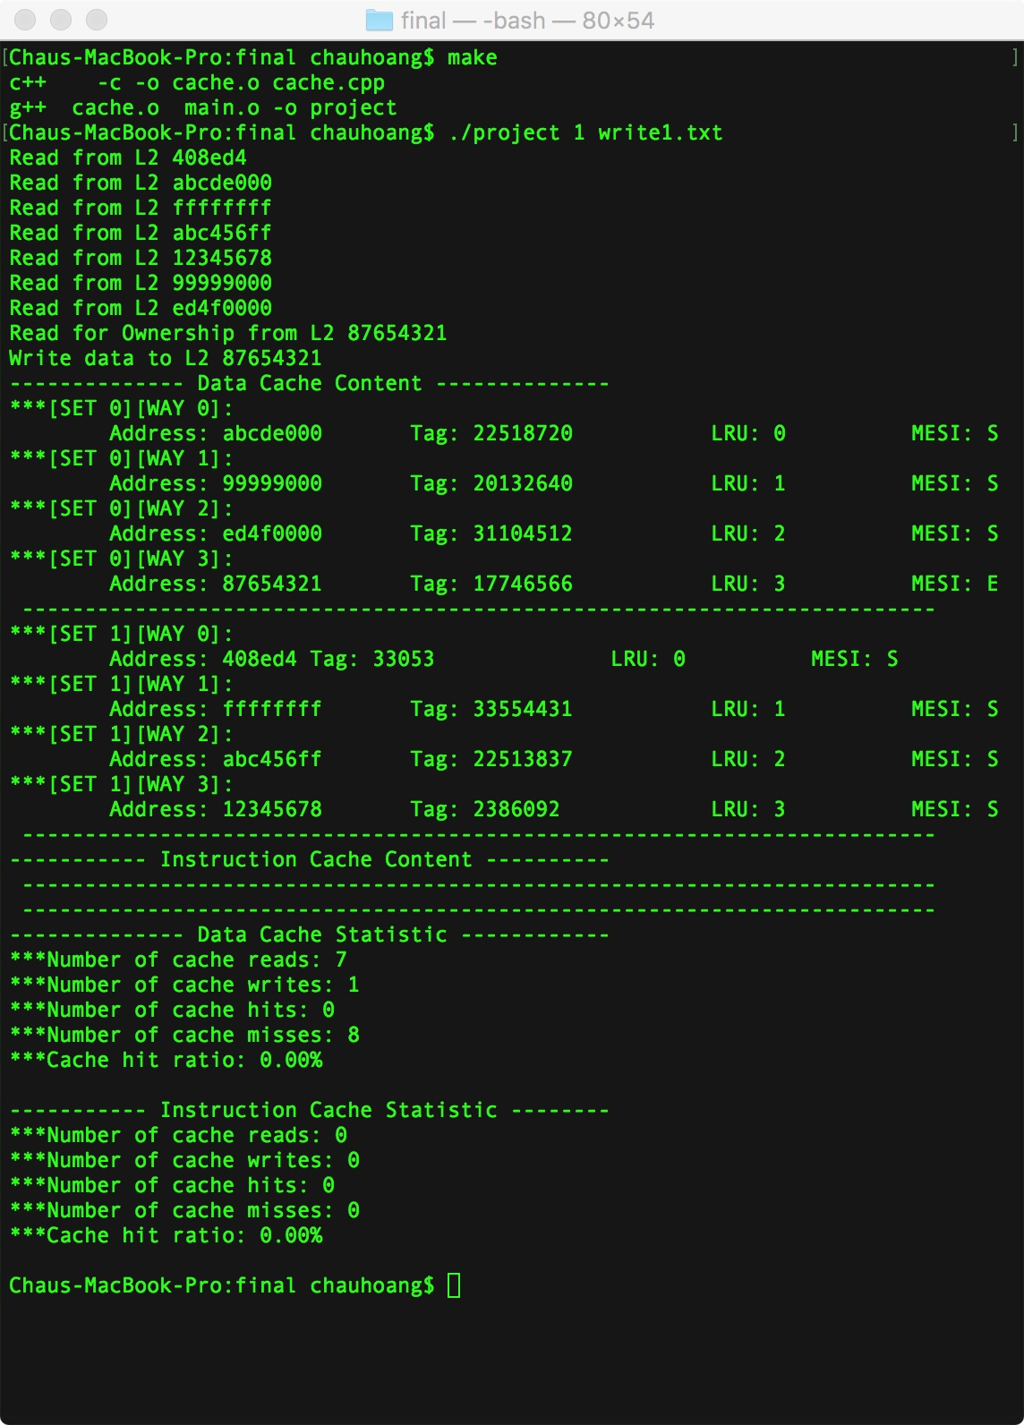

|  |  |  |  |
| --- | --- | --- | --- |
| Case | Address | Expected Results | Verify |
| 2 | 0 408ed4  0 abcde000  0 ffffffff  0 abc456ff  0 12345678  0 99999000  0 ed4f0004  1 87654321 // this is write to set 0 way 3  1 87654321// updare MESI: M  9 0000000 | Set 0:  Way 0: LRU 0: MESI : S  Way 1: LRU 1: MESI : S  Way 2: LRU 2: MESI: S  Way 3: LRU 3: MESI: M  Set 1:  Way 0: LRU 0: MESI : S  Way 1: LRU 1: MESI : S  Way 2: LRU 2: MESI: S  Way 3: LRU 3: MESI: S  It will print out the message Read for Ownership from L2<ADDRESS>  Data Caches:  Caches Read: 7  Caches hit : 1  Caches miss: 8  Caches write : 2  Hit Ratio: 11.11%  Instruction Caches:  Caches Read: 0  Caches hit : 0  Caches miss: 0  Hit Ratio: 0.00% | Yes |

Program output:

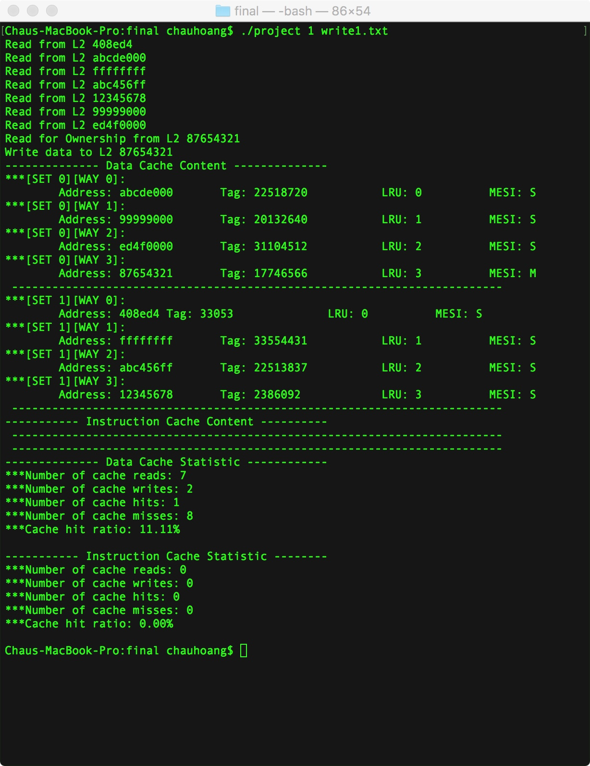

|  |  |  |  |
| --- | --- | --- | --- |
| Case | Address | Expected Results | Verify |
| 3 | 0 408ed4  0 abcde000// it is LRU. Evict for write miss  0 ffffffff  0 abc456ff  0 12345678  0 99999000  0 ed4f0000  0 678abc9f  1 87654321// write miss here  9 00000000 | Set 0:  Way 0: LRU 3: MESI : E  Way 1: LRU 0: MESI : S  Way 2: LRU 1: MESI: S  Way 3: LRU 2: MESI: S  Set 1:  Way 0: LRU 0: MESI : S  Way 1: LRU 1: MESI : S  Way 2: LRU 2: MESI: S  Way 3: LRU 3: MESI: S  It will print out the message Read for Ownership from L2<ADDRESS>  Data Caches:  Caches Read: 8  Caches hit : 0  Caches miss: 8  Caches write : 1  Hit Ratio: 00.00%  Instruction Caches:  Caches Read: 0  Caches hit : 0  Caches miss: 0  Hit Ratio: 0.00% | Yes |

Program output:

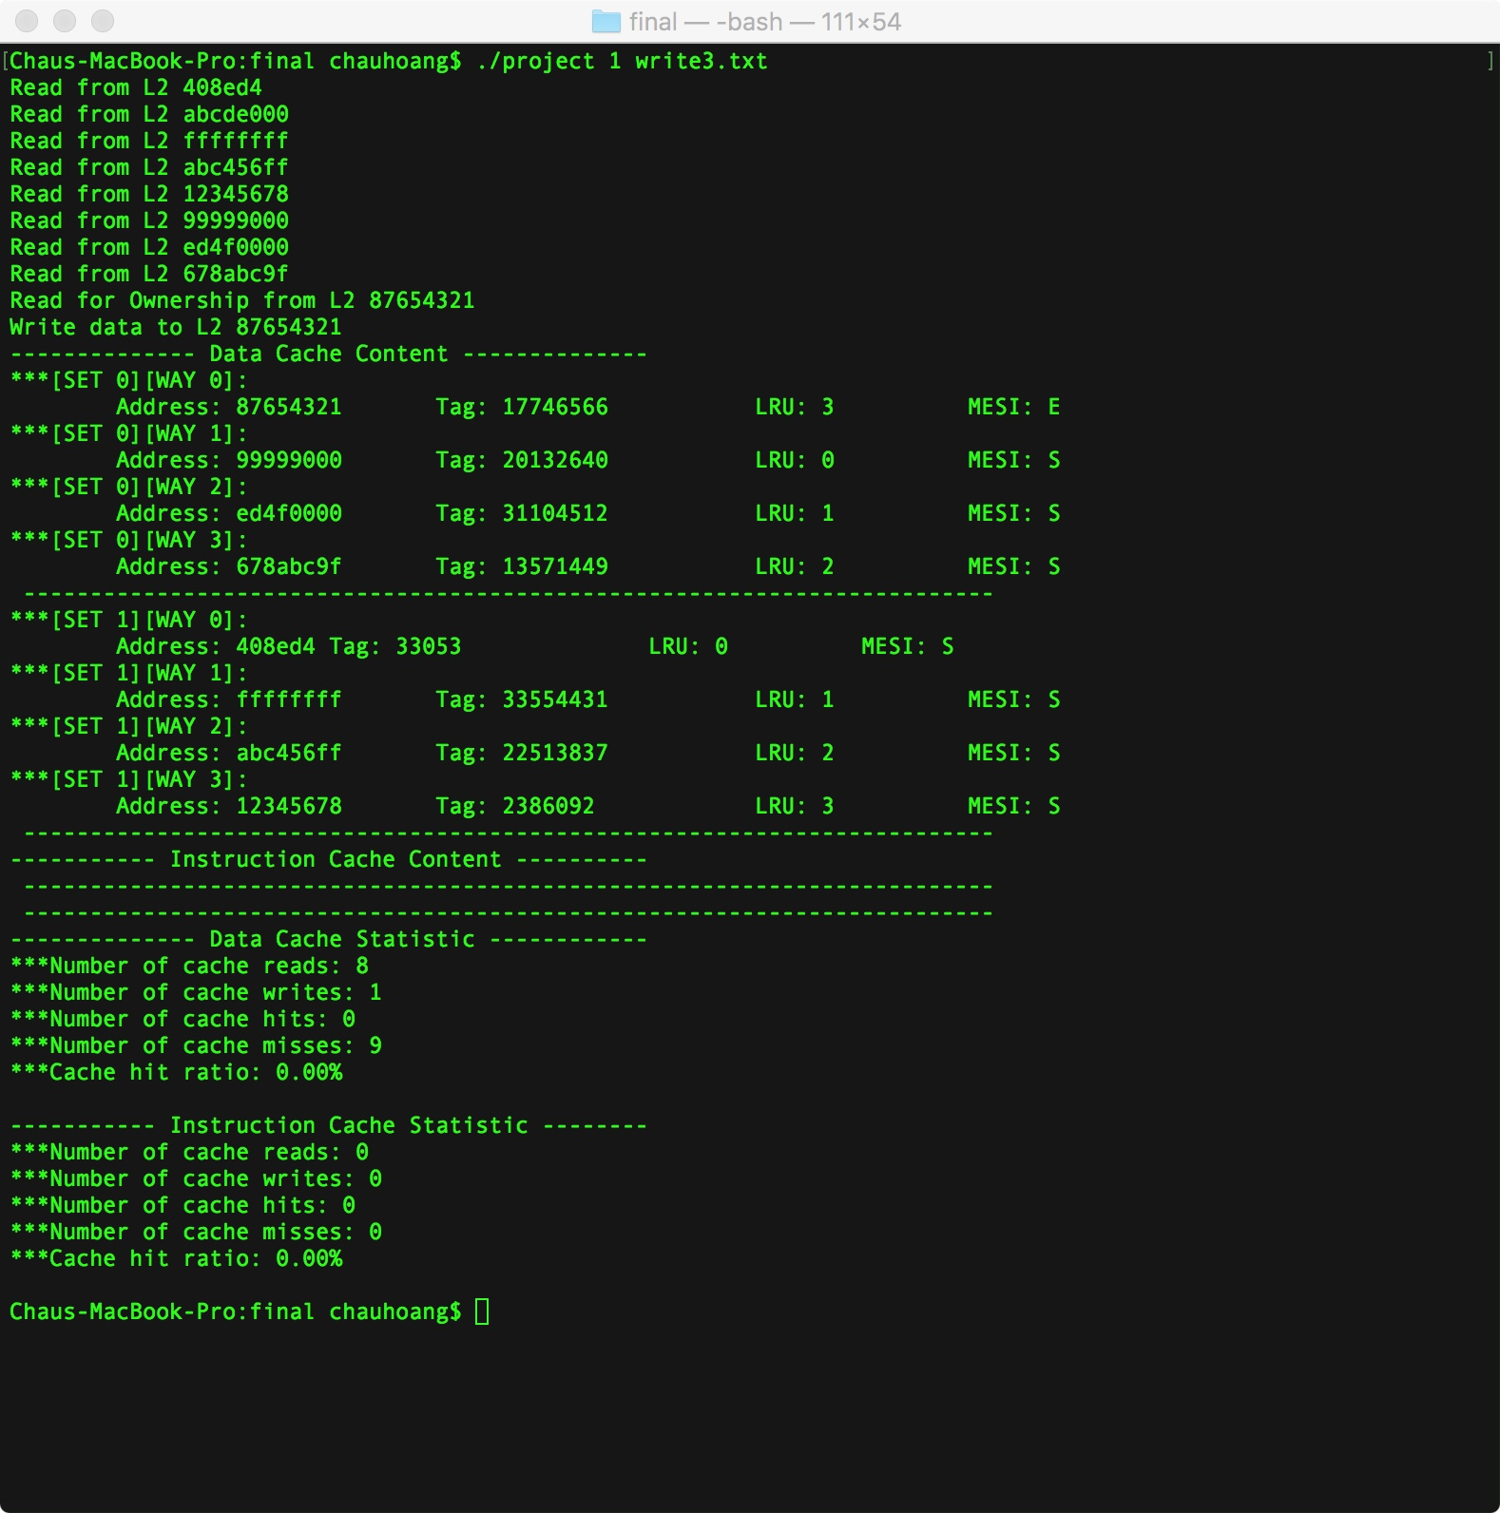

|  |  |  |  |
| --- | --- | --- | --- |
| Case | Address | Expected Results | Verify |
| 4 | 0 408ed4  0 abcde000  0 ffffffff  0 abc456ff  0 12345678  0 99999000  0 ed4f0000  0 678abc9f  0 abcde000  1 87654321// write miss here  9 00000000 | Set 0:  Way 0: LRU 2: MESI : S  Way 1: LRU 3: MESI : E  Way 2: LRU 0: MESI: S  Way 3: LRU 1: MESI: S  Set 1:  Way 0: LRU 0: MESI : S  Way 1: LRU 1: MESI : S  Way 2: LRU 2: MESI: S  Way 3: LRU 3: MESI: S  It will print out the message Read for Ownership from L2<ADDRESS>  Data Caches:  Caches Read: 9  Caches hit : 1  Caches miss: 9  Caches write : 1  Hit Ratio: 10.00%  Instruction Caches:  Caches Read: 0  Caches hit : 0  Caches miss: 0  Hit Ratio: 0.00% | Yes |

Program output:

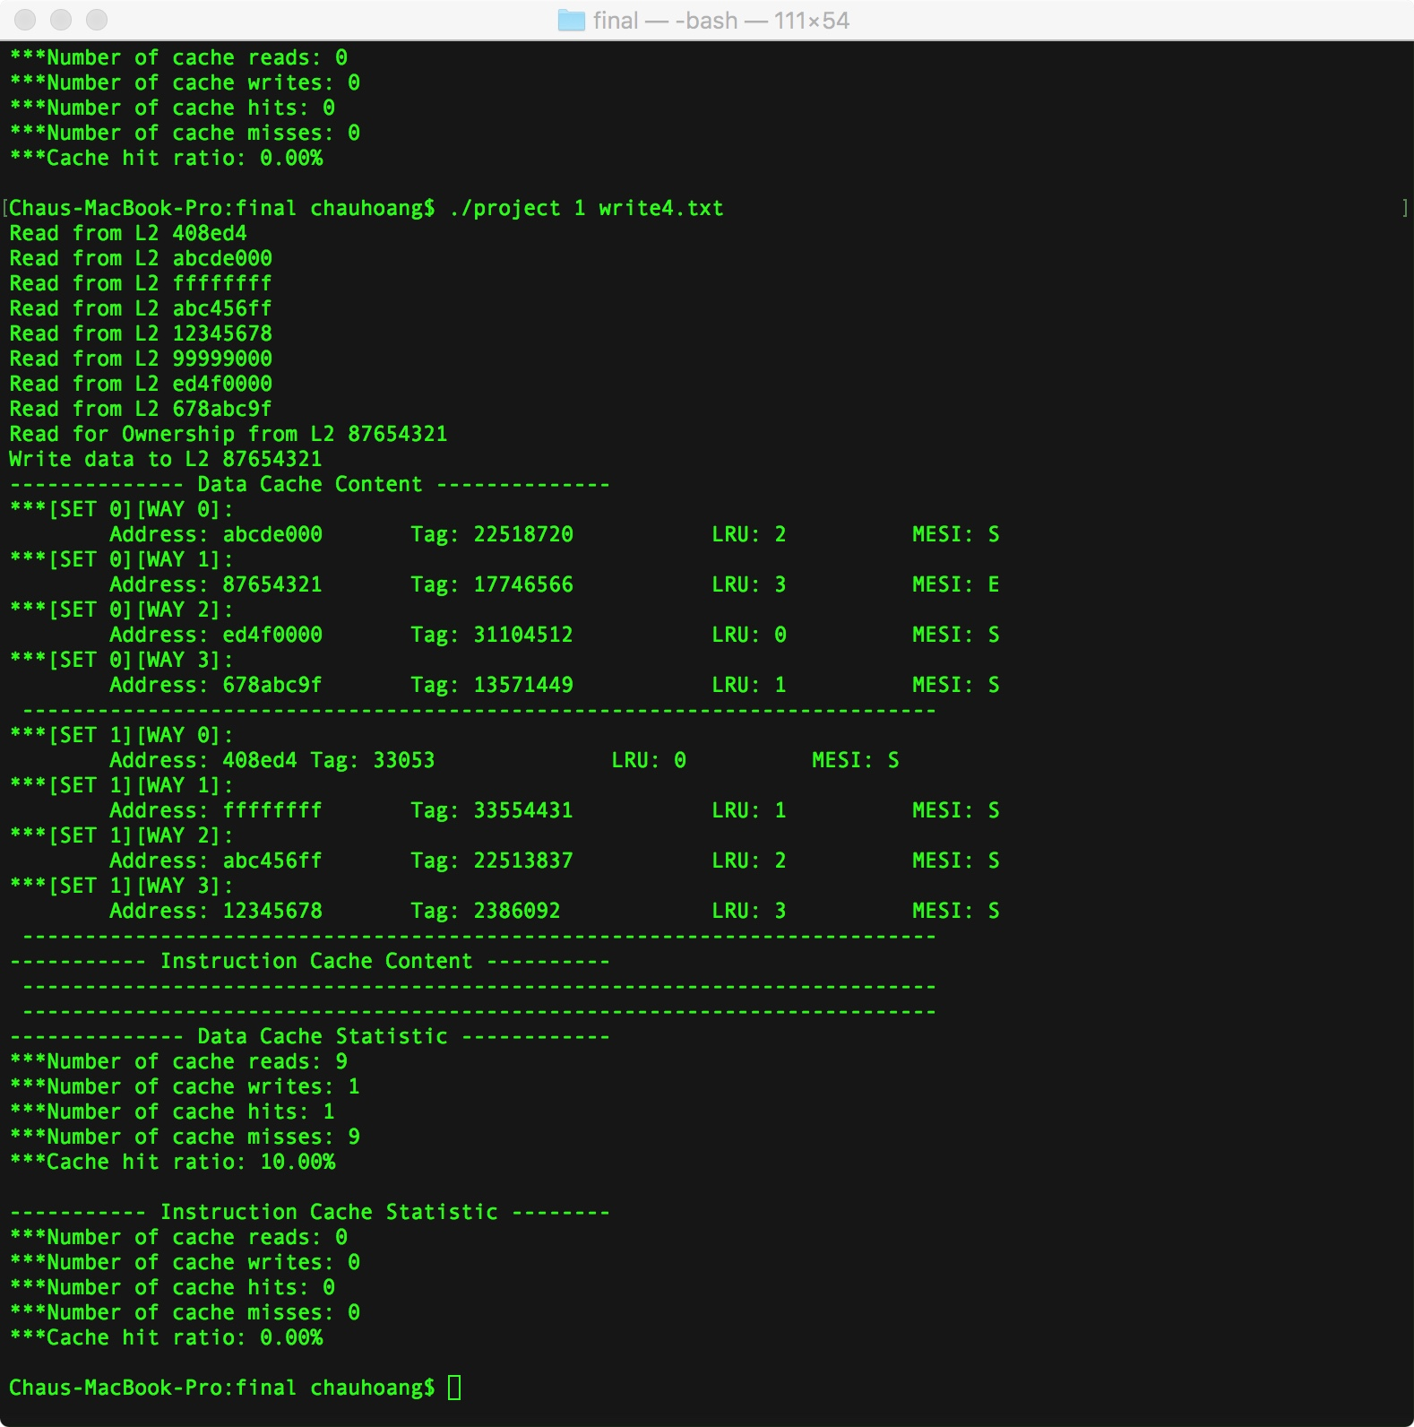

|  |  |  |  |
| --- | --- | --- | --- |
| Case | Address | Expected Results | Verify |
| 5 | 0 408ed4  0 abcde000  0 ffffffff  0 abc456ff  0 12345678  0 99999000  0 ed4f0000  0 abcde000  1 87654321// write miss here  9 00000000 | Set 0:  Way 0: LRU 2: MESI : S  Way 1: LRU 0: MESI : S  Way 2: LRU 1: MESI: S  Way 3: LRU 3: MESI: E  Set 1:  Way 0: LRU 0: MESI : S  Way 1: LRU 1: MESI : S  Way 2: LRU 2: MESI: S  Way 3: LRU 3: MESI: S  It will print out the message Read for Ownership from L2<ADDRESS>  Data Caches:  Caches Read: 8  Caches hit : 1  Caches miss: 8  Caches write : 1  Hit Ratio: 11.11%  Instruction Caches:  Caches Read: 0  Caches hit : 0  Caches miss: 0  Hit Ratio: 0.00% | Yes |

Program Output:

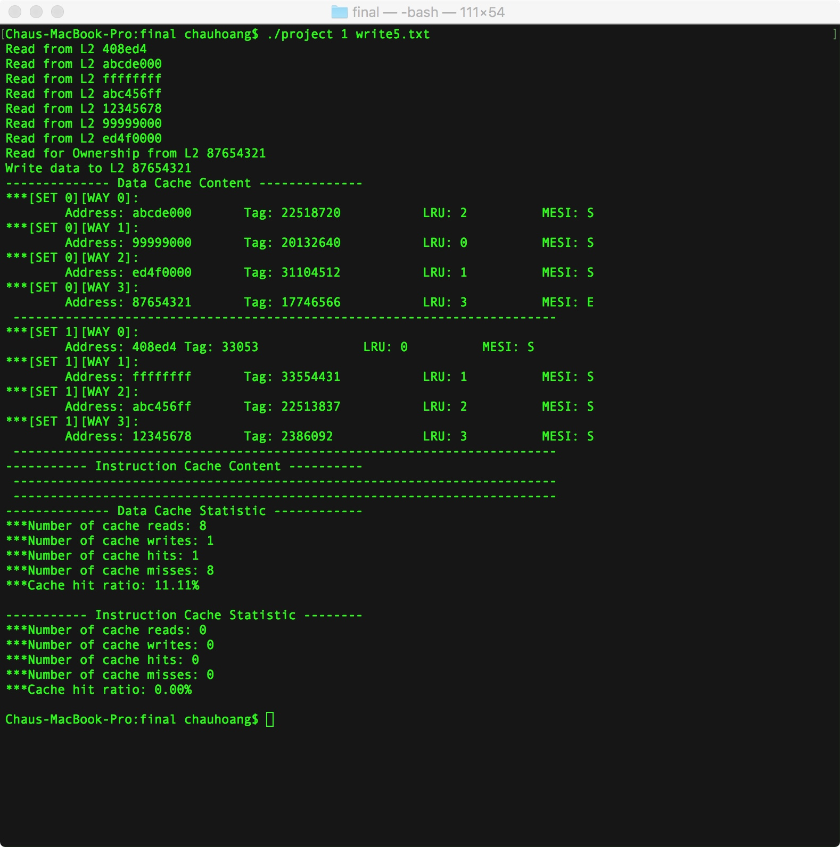

|  |  |  |  |
| --- | --- | --- | --- |
| Case | Address | Expected Results | Verify |
| 6 | 0 408ed4  0 abcde000  0 ffffffff  0 abc456ff  0 12345678  0 99999000  0 ed4f0000  0 abcde000  1 87654321// write miss here  1 87654321  0 abcde000  0 99999000  0 ed4f0000  1 97654321  9 00000000 | Set 0:  Way 0: LRU 0: MESI : S  Way 1: LRU 1: MESI : S  Way 2: LRU 2: MESI: S  Way 3: LRU 3: MESI: E  Set 1:  Way 0: LRU 0: MESI : S  Way 1: LRU 1: MESI : S  Way 2: LRU 2: MESI: S  Way 3: LRU 3: MESI: S  It will print out the message Read for Ownership from L2<ADDRESS>  Write data to L2<87654321>  Data Caches:  Caches Read: 11  Caches hit : 5  Caches miss: 9  Caches write : 3  Hit Ratio: 35.71%  Instruction Caches:  Caches Read: 0  Caches hit : 0  Caches miss: 0  Hit Ratio: 0.00% | Yes |

Program output:

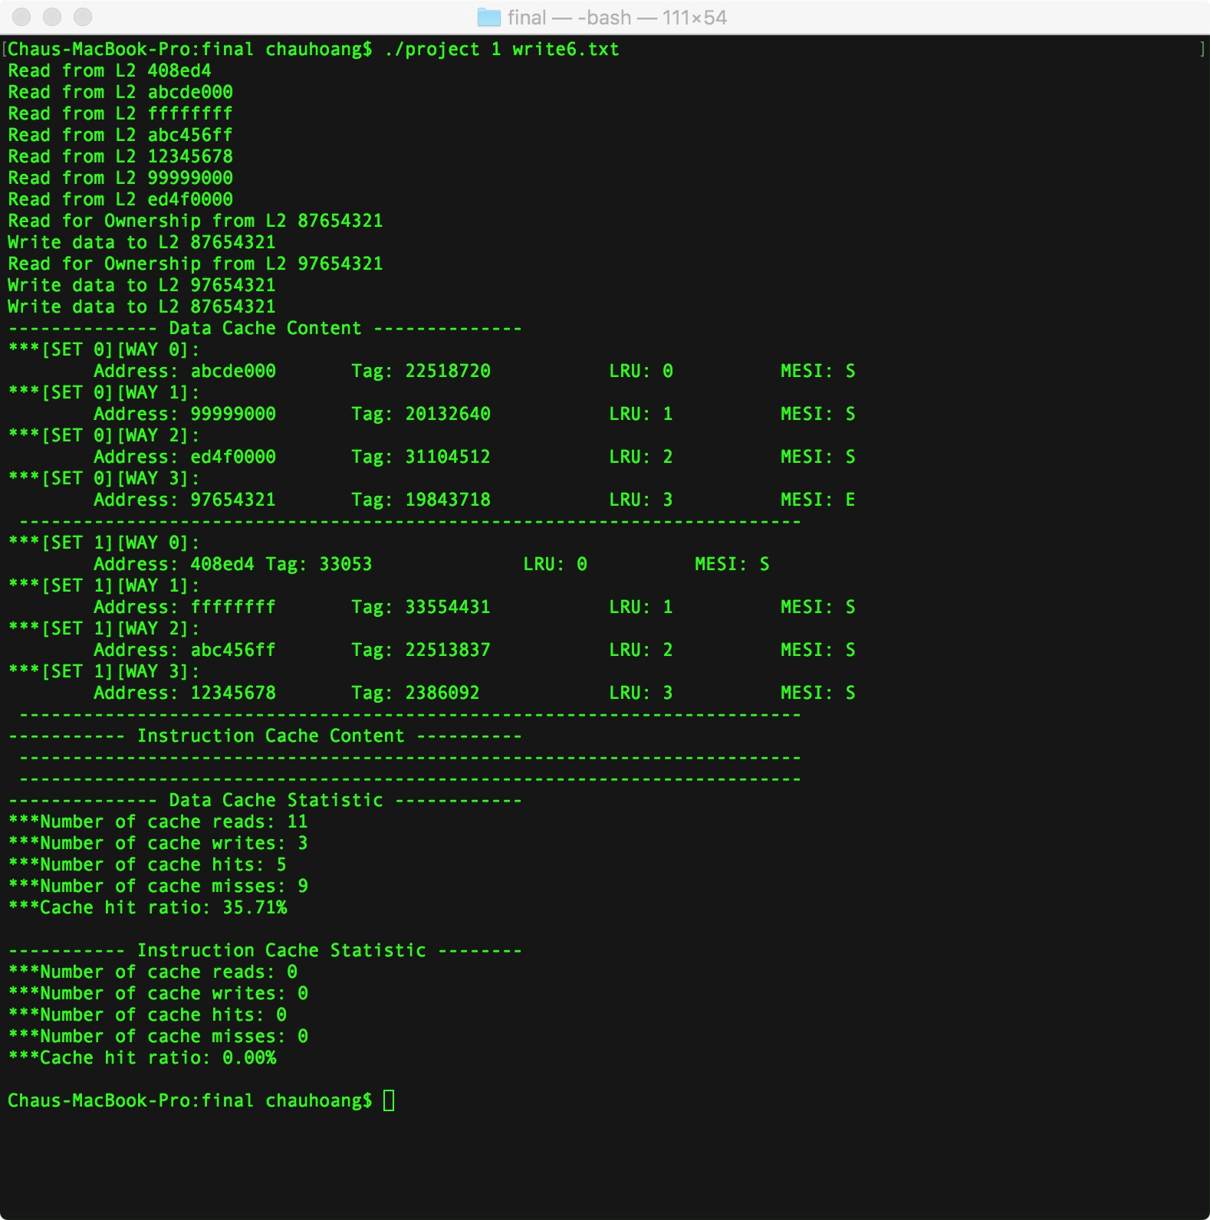

Instruction fetch test:

1. Test with read/write and instruction fetch because instruction caches is separate so the LRU and MESI bit is separate too. This test only check to see if the instruction fetch update LRU bit and MESI correct

|  |  |  |  |
| --- | --- | --- | --- |
| Case | Address | Expected Results | Verify |
| 1 | 0 408ed4  0 abcde000  0 ffffffff  0 abc456ff  0 12345678  0 99999000  0 ed4f0000  0 678abc9f  9 00000000 | Data caches  Set 0:  Way 0: LRU 0: MESI : S  Way 1: LRU 1: MESI : S  Way 2: LRU 2: MESI: S  Way 3: LRU 3: MESI: S  Set 1:  Way 0: LRU 0: MESI : S  Way 1: LRU 1: MESI : S  Way 2: LRU 2: MESI: S  Way 3: LRU 3: MESI: S  Instruction Caches  Set 0:  Way 0: LRU 0: MESI : S  Way 1: LRU 1: MESI : S    Set 1:  Way 0: LRU 0: MESI : S  Way 1: LRU 1: MESI : S  Data Caches:  Caches Read: 8  Caches hit : 0  Caches miss: 8  Hit Ratio: 0.00%  Instruction Caches:  Caches Read: 4  Caches hit : 0  Caches miss: 4  Hit Ratio: 0.00% | Yes. |
|  |  |  |  |

Program output:

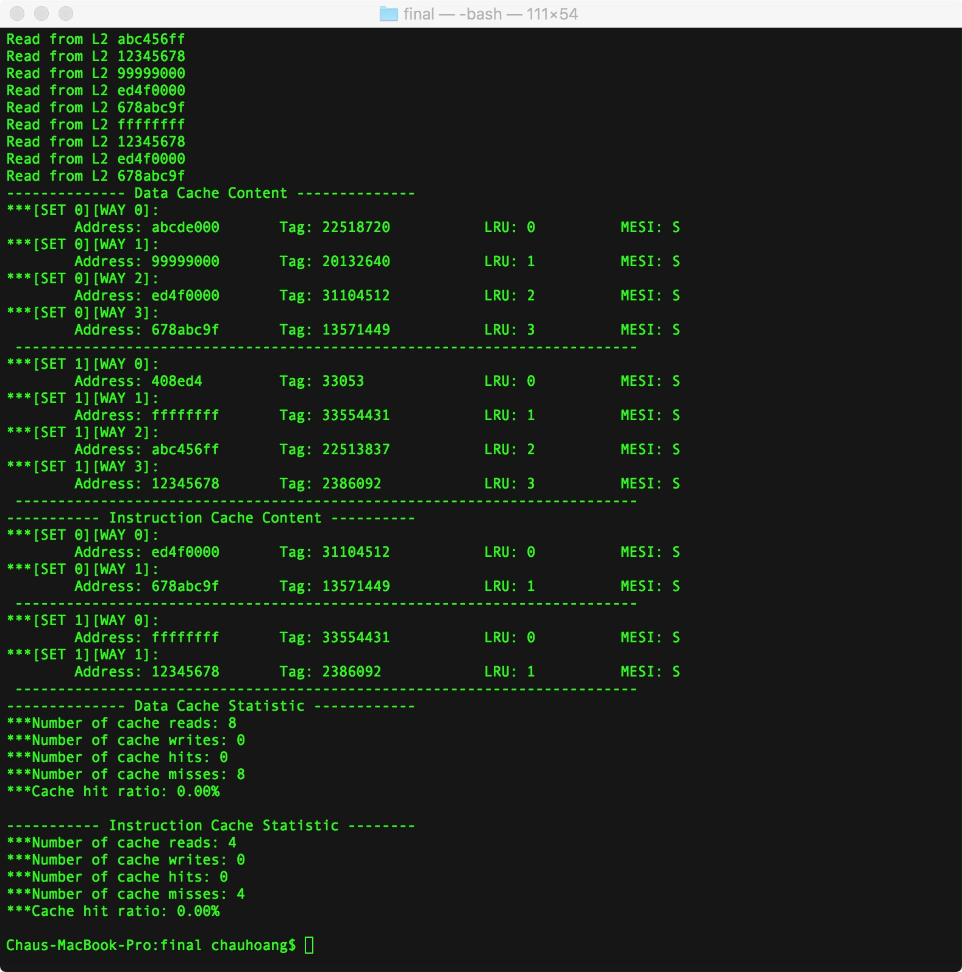

Invalidate command from L2

1. We will invalidate the data response to L2 snooping, but the Cache line will be In S state, when the cache line invalidate, it wont return data to L2 because it is S state. We just update LRU bit for the cache.
2. Second we will invalidate the M line in cache line, it will print out message return data to L2<address> and update LRU bit.
3. We will combine test 1 and 2 together.

|  |  |  |  |
| --- | --- | --- | --- |
| Case | Address | Expected Results | Verify |
| 1 | 0 408ed4  0 abcde000  0 ffffffff  0 abc456ff  0 12345678  0 99999000  4 abc456ff // Invalidate this data  0 ed4f0000  0 678abc9f  9 00000000 | Set 0:  Way 0: LRU 0: MESI : S  Way 1: LRU 1: MESI : S  Way 2: LRU 2: MESI: S  Way 3: LRU 3: MESI: S  Set 1:  Way 0: LRU 1: MESI : S    Way 1: LRU 3: MESI: S  Way 2: LRU 2: MESI: S  Data Caches:  Caches Read: 8  Caches hit : 0  Caches miss: 8  Caches write : 0  Hit Ratio: 00.00%  Instruction Caches:  Caches Read: 0  Caches hit : 0  Caches miss: 0  Hit Ratio: 0.00% | Yes |

FYI: In the set 1 we don’t have the LRU bit = 0 because we still have the spot available, so whenever we read or write data to this set, we don’t need to evict the line. Just read/write to the spot, after it the LRU will be update.

Program output:

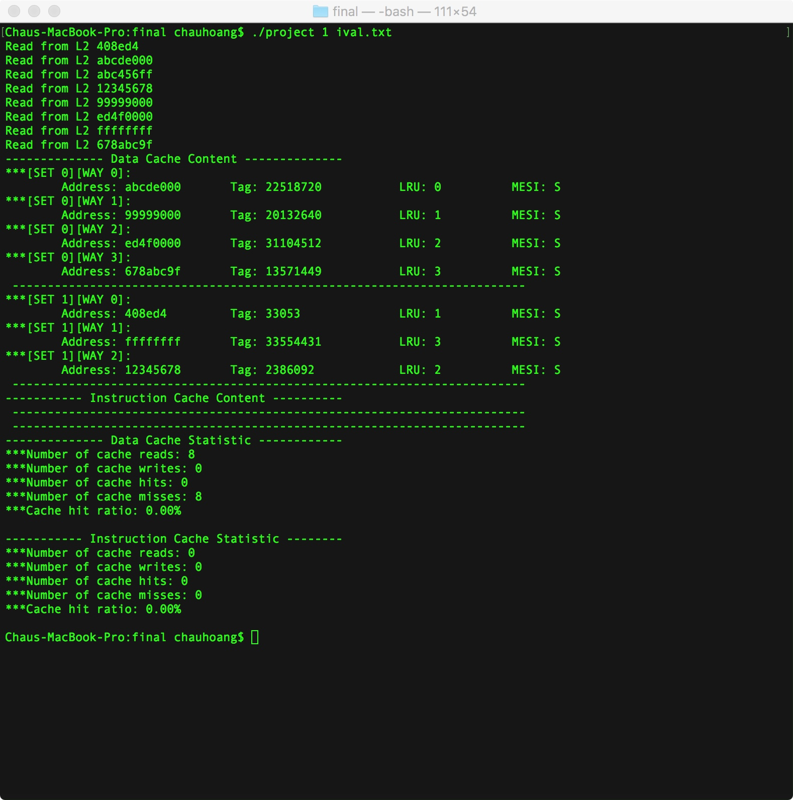

|  |  |  |  |
| --- | --- | --- | --- |
| Case | Address | Expected Results | Verify |
| 2 | 0 408ed4  0 abcde000  0 ffffffff  0 abc456ff  0 12345678  0 99999000  0 ed4f0004  1 87654321 // this is write to set 0 way 3  1 87654321// updare MESI: M  3 87654321// evict the M line  9 0000000 | Set 0:  Way 0: LRU 1: MESI : S  Way 1: LRU 2: MESI : S  Way 2: LRU 3: MESI: S    Set 1:  Way 0: LRU 0: MESI : S  Way 1: LRU 1: MESI: S  Way 2: LRU 2: MESI: S  Way 3: LRU 3: MESI S  It will print out message Return data to L2<address>  Data Caches:  Caches Read: 7  Caches hit : 1  Caches miss: 8  Caches write : 2  Hit Ratio: 11.11%  Instruction Caches:  Caches Read: 0  Caches hit : 0  Caches miss: 0  Hit Ratio: 0.00% | Yes |

Program output:

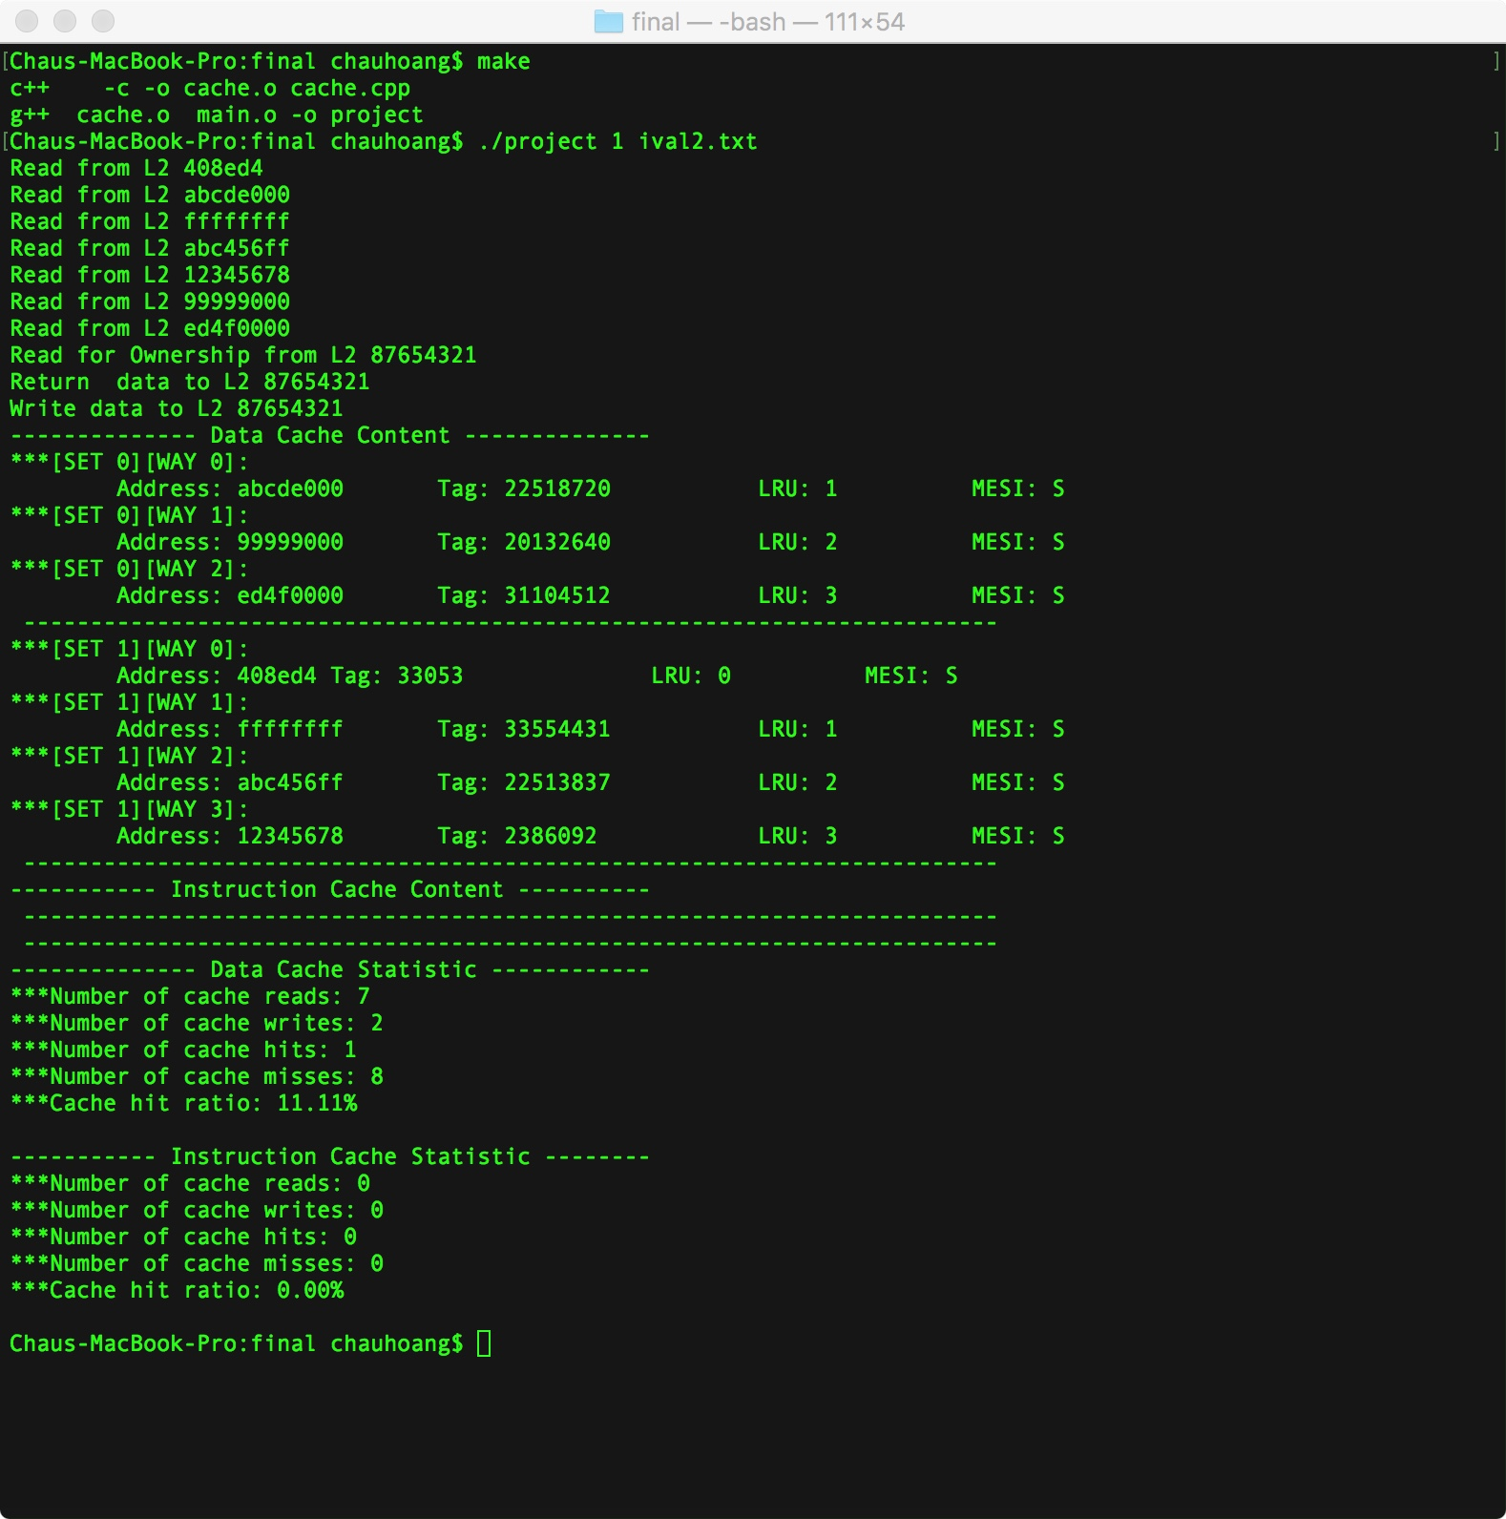

|  |  |  |  |
| --- | --- | --- | --- |
| Case | Address | Expected Results | Verify |
| 3 | 0 408ed4  0 abcde000  0 ffffffff  0 abc456ff  0 12345678  0 99999000  0 ed4f0004  3 408ed4  1 87654321 // this is write to set 0 way 3  1 87654321// updare MESI: M  3 87654321// evict the M line  9 0000000 | Set 0:  Way 0: LRU 1: MESI : S  Way 1: LRU 2: MESI : S  Way 2: LRU 3: MESI: S    Set 1:  Way 1: LRU 1: MESI : S  Way 2: LRU 2: MESI: S  Way 3: LRU 3: MESI: S  It will print out message Return data to L2<address>  Data Caches:  Caches Read: 7  Caches hit : 1  Caches miss: 8  Caches write : 2  Hit Ratio: 11.11%  Instruction Caches:  Caches Read: 0  Caches hit : 0  Caches miss: 0  Hit Ratio: 0.00% | Yes |

Program output:

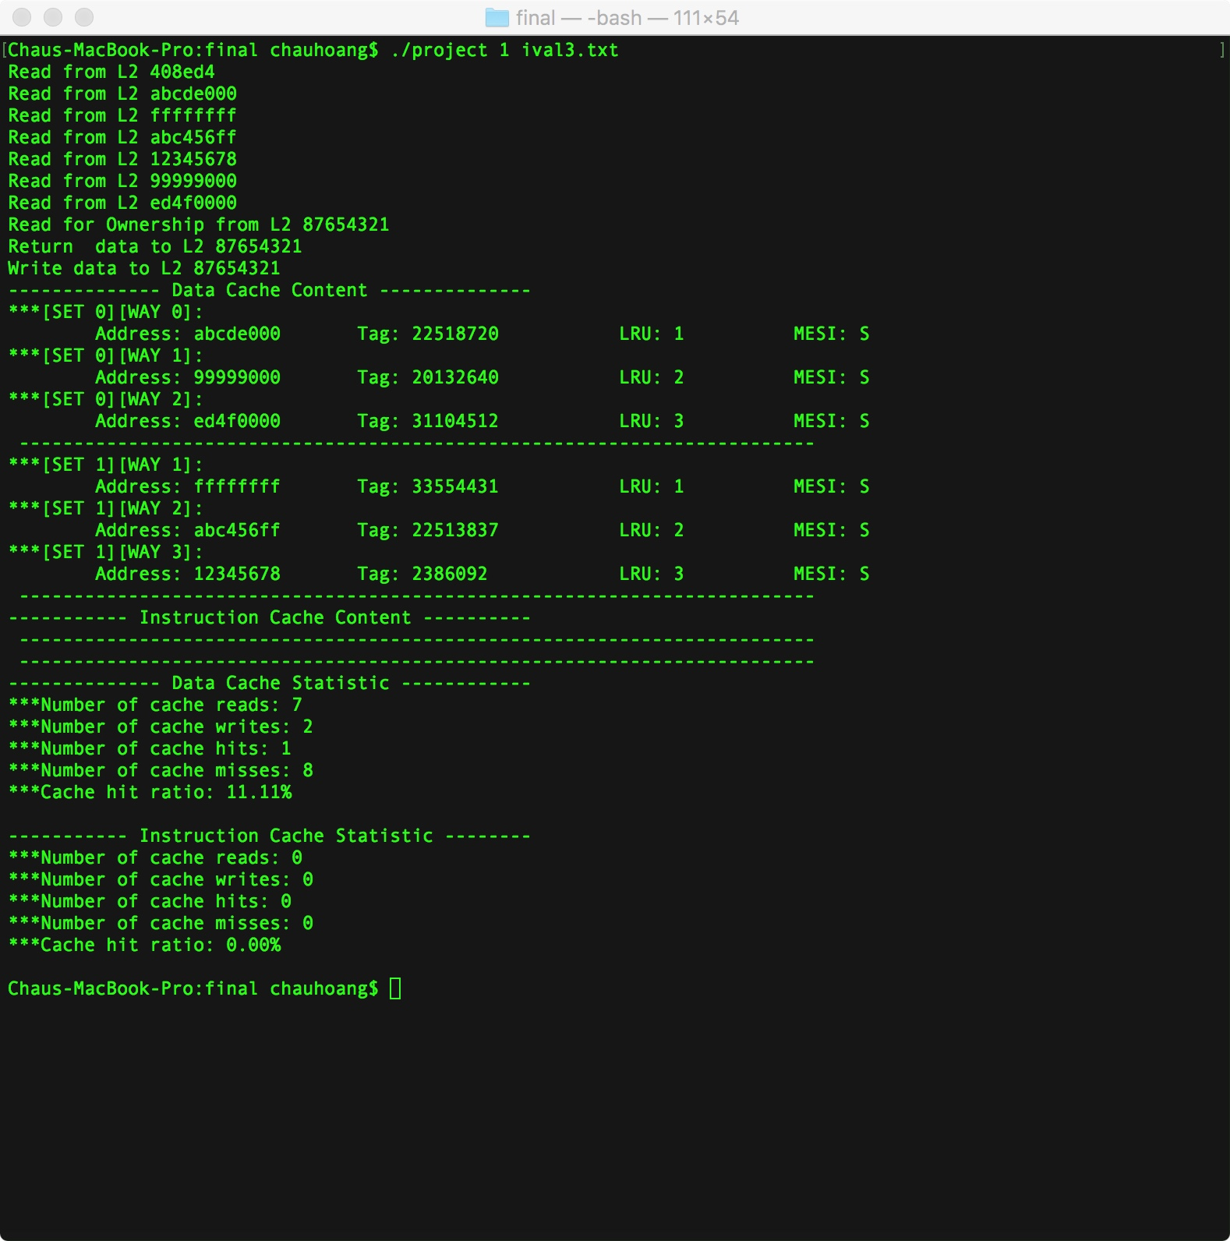

Date Request from L2

1. First we will request data from L2 when this cache line is S state. MESI bit stay the S
2. Second we will request date from L2 when this cache line E state-> the MESI bit stay E
3. Third will request date from L2 when this cache line M state-> the MESI bit stay S

FYI: LRU bit for the date request from L2 not update because it is not CPU request.

|  |  |  |  |
| --- | --- | --- | --- |
| Case | Address | Expected Results | Verify |
| 1 | 0 408ed4  0 abcde000  0 ffffffff  0 abc456ff  0 12345678  0 99999000  0 ed4f0004  4 408ed4// data request from L2  9 0000000 | Set 0:  Way 0: LRU 1: MESI : S  Way 1: LRU 2: MESI : S  Way 2: LRU 3: MESI: S    Set 1:  Way 0: LRU 0: MESI :S  Way 1: LRU 1: MESI : S  Way 2: LRU 2: MESI: S  Way 3: LRU 3: MESI: S    Data Caches:  Caches Read: 7  Caches hit : 0  Caches miss: 7  Caches write : 0  Hit Ratio: 00.00%  Instruction Caches:  Caches Read: 0  Caches hit : 0  Caches miss: 0  Hit Ratio: 0.00% | Yes |

Program output:

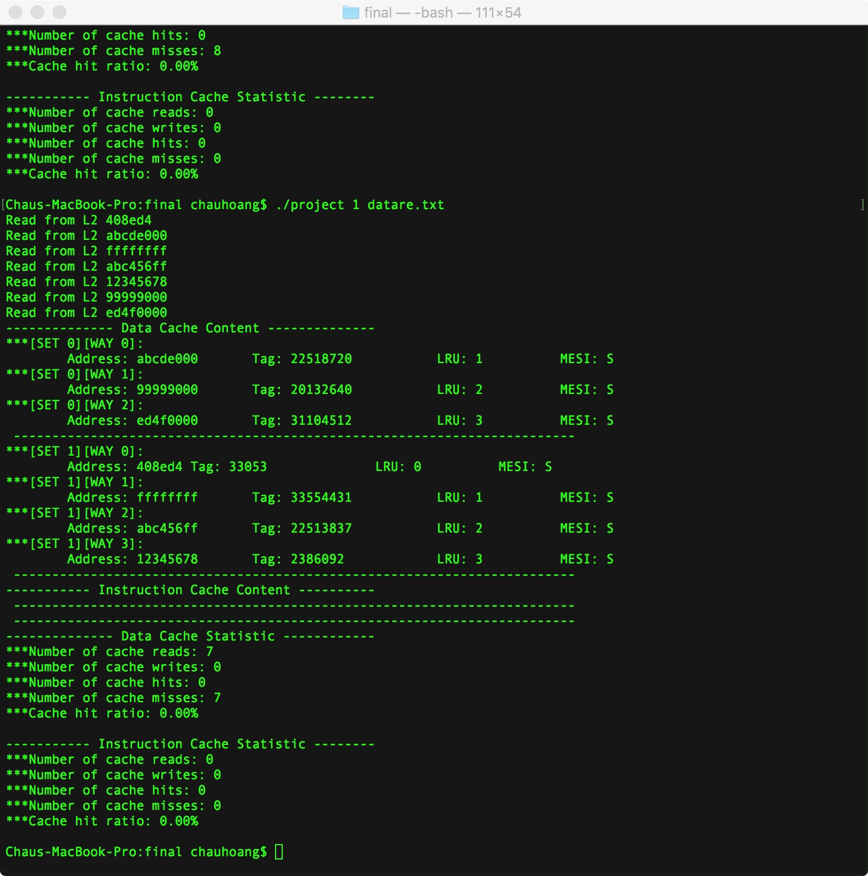

|  |  |  |  |
| --- | --- | --- | --- |
| Case | Address | Expected Results | Verify |
| 2 | 0 408ed4  0 abcde000  0 ffffffff  0 abc456ff  0 12345678  0 99999000  0 ed4f0004  1 87654321// write to cache miss  1 87654321// data request from L2 MESI BIT IS E  9 0000000 | Set 0:  Way 0: LRU 0: MESI : S  Way 1: LRU 1: MESI : S  Way 2: LRU 2: MESI: S  Way 3: LRU 3: MESI : E    Set 1:  Way 0: LRU 0: MESI :S  Way 1: LRU 1: MESI : S  Way 2: LRU 2: MESI: S  Way 3: LRU 3: MESI: S  Return data to L2<address>    Data Caches:  Caches Read: 7  Caches hit : 1  Caches miss: 8  Caches write : 0  Hit Ratio: 00.00%  Instruction Caches:  Caches Read: 0  Caches hit : 0  Caches miss: 0  Hit Ratio: 0.00% | Yes |

Program output

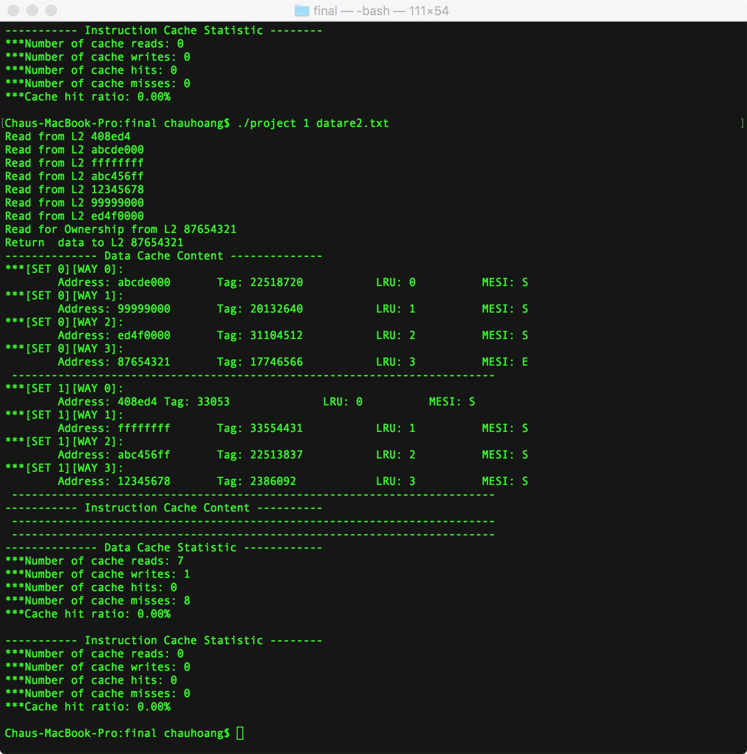

|  |  |  |  |
| --- | --- | --- | --- |
| Case | Address | Expected Results | Verify |
| 3 | 0 408ed4  0 abcde000  0 ffffffff  0 abc456ff  0 12345678  0 99999000  0 ed4f0000  1 87654321 // this is write to set 0 way 3  1 87654321// updare MESI: M  4 87654321 // it should change MESI bit to S  9 0000000 | Set 0:  Way 0: LRU 0: MESI : S  Way 1: LRU 1: MESI : S  Way 2: LRU 2: MESI: S  Way 3: LRU 3: MESI : S    Set 1:  Way 0: LRU 0: MESI :S  Way 1: LRU 1: MESI : S  Way 2: LRU 2: MESI: S  Way 3: LRU 3: MESI: S  Return data to L2<address>    Data Caches:  Caches Read: 7  Caches hit : 1  Caches miss: 8  Caches write : 2  Hit Ratio: 11.11%  Instruction Caches:  Caches Read: 0  Caches hit : 0  Caches miss: 0  Hit Ratio: 0.00% | Yes |

Program output:

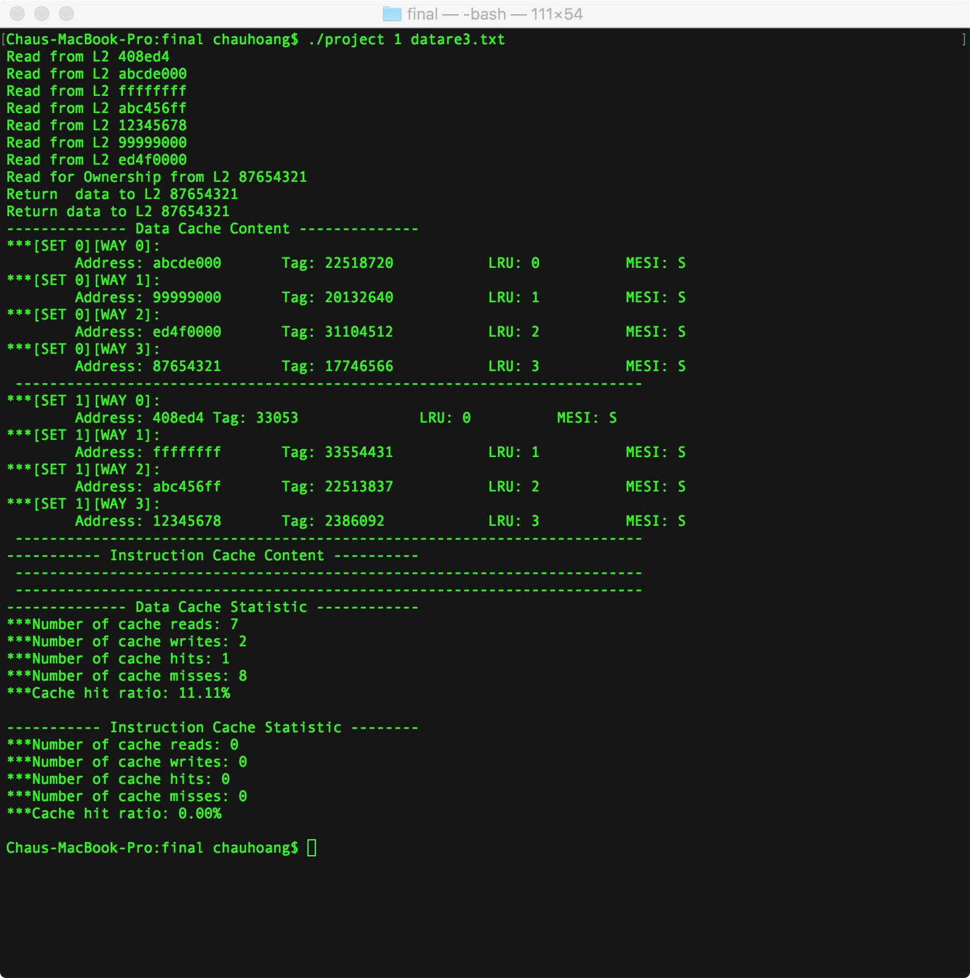

Clear the Cache and reset all state

1. The caches will have some data in it and clean the Cache
2. The caches will have some data in it and clean the cache then input more data.

|  |  |  |  |
| --- | --- | --- | --- |
| Case | Address | Expected Results | Verify |
| 1 | 0 408ed4  0 abcde000  0 ffffffff  0 abc456ff  0 12345678  0 99999000  0 ed4f0000  1 87654321  1 87654321  8 f2356789  9 0000000 | Nothing display in cache Line  Data Caches:  Caches Read: 0  Caches hit : 0  Caches miss:0  Caches write : 0  Hit Ratio: 00.00%  Instruction Caches:  Caches Read: 0  Caches hit : 0  Caches miss: 0  Hit Ratio: 0.00% | Yes |

Program Output :

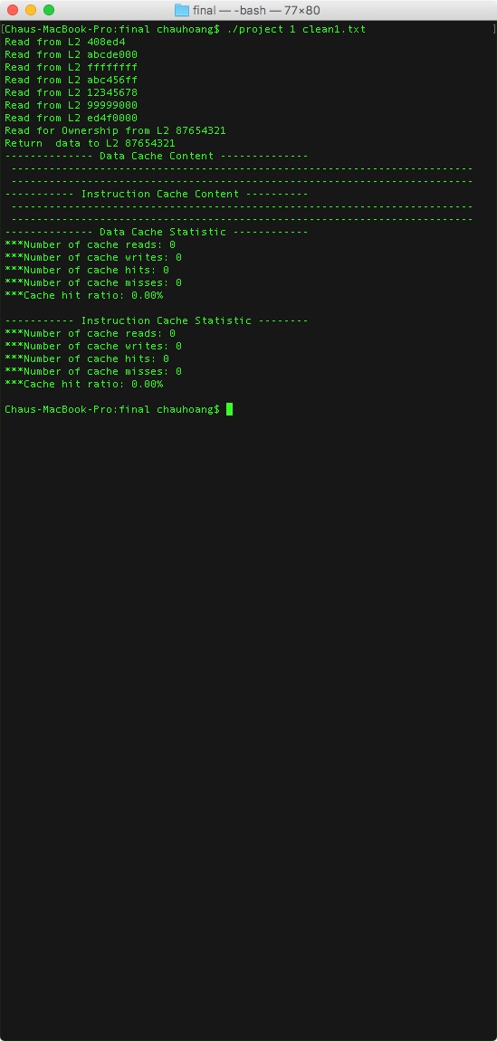

|  |  |  |  |
| --- | --- | --- | --- |
| Case | Address | Expected Results | Verify |
| 2 | 0 408ed4  0 abcde000  0 ffffffff  0 abc456ff  0 12345678  0 99999000  0 ed4f0000  1 87654321  1 87654321  8 f2356789  9 0000000  1 abcedef  0 765abcd  1 5678900  0 09abcde  9 0000000 | Set 0:  Way 0: LRU 3: MESI : S      Set 1:  Way 0: LRU 0: MESI :S  Way 1: LRU 1: MESI : S  Way 2: LRU 2: MESI: S  Data Caches:  Caches Read: 2  Caches hit : 0  Caches miss: 4  Caches write : 2  Hit Ratio: 0.00%  Instruction Caches:  Caches Read: 0  Caches hit : 0  Caches miss: 0  Hit Ratio: 0.00% | Yes |

Program output:

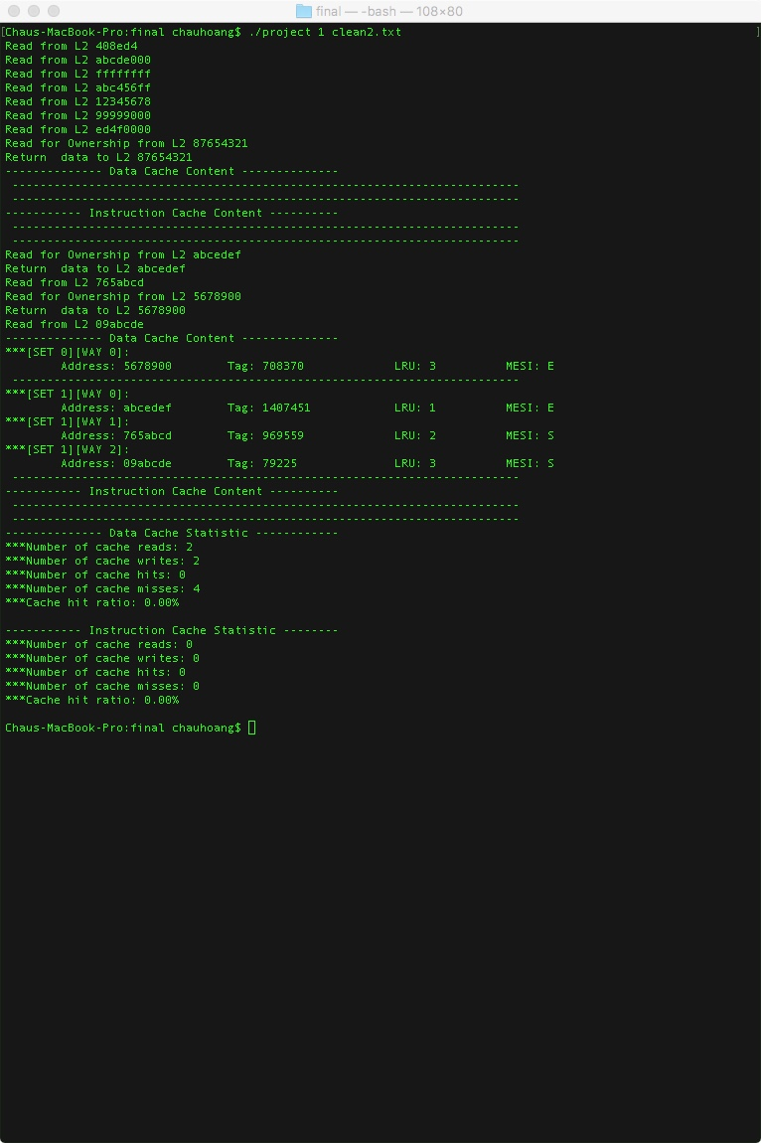

Final Test is test everything by the trace file from course website..

